**Finance Investment**

Program:

import java.util.Scanner;

class Finance

{

    public static double predictFinance(double amount , double rate , int year)

    {

        if (year == 0)

            return amount;

        else

            return (rate+1) * predictFinance(amount , rate, year-1);

    }

    public static void main(String[] args) {

        Scanner sc = new Scanner(System.in);

        System.out.println("Enter the initial amount of investment");

        double amount = sc.nextDouble();

        System.out.println("Enter the rate of increase per year");

        double rate = sc.nextDouble();

        System.out.println("Enter the year of investment");

        int year = sc.nextInt();

        System.out.printf("After %d years the amount wil become %.2f" , year, predictFinance(amount, rate, year));

    }

}

**Output:**

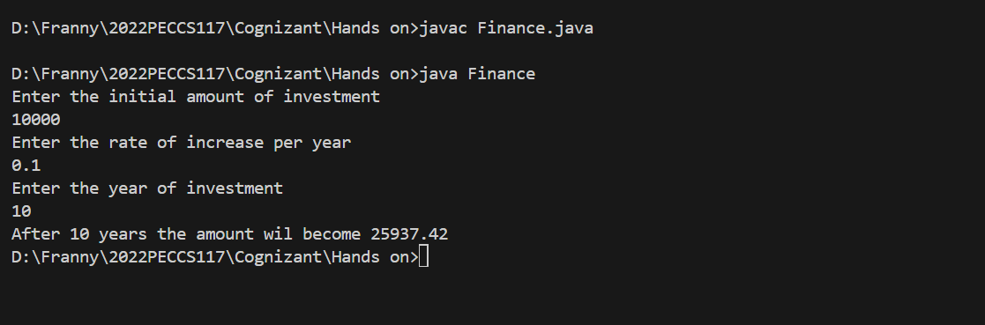

**Recursion:**

Recursion is the concept of calling itself to break down the problem into easily solvable code. They primarily use the concept of Stack, which will store the previously computed results and use when needed.

Recursion can be used for smaller problems as if used for bigger ones it may lead to StackOverflowError in java. Recursion can take a lot of time for bigger problems and so not as optimal as other solutions.